**Republic of Congo country profile**

Published

8 January 2018

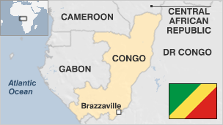

**Civil wars and militia conflicts have plagued the Republic of Congo, which is sometimes referred to as Congo-Brazzaville.**

Nearly half the population lives in poverty, according to the World Bank, even though the Republic of Congo is one of sub-Saharan Africa's main oil producers.

Oil is the mainstay of the economy and in recent years the country has tried to increase financial transparency in the sector.

* Read [more country profiles](http://news.bbc.co.uk/1/hi/country_profiles/) - Profiles by [BBC Monitoring](http://www.bbc.co.uk/monitoring)

**President: Denis Sassou Nguesso**

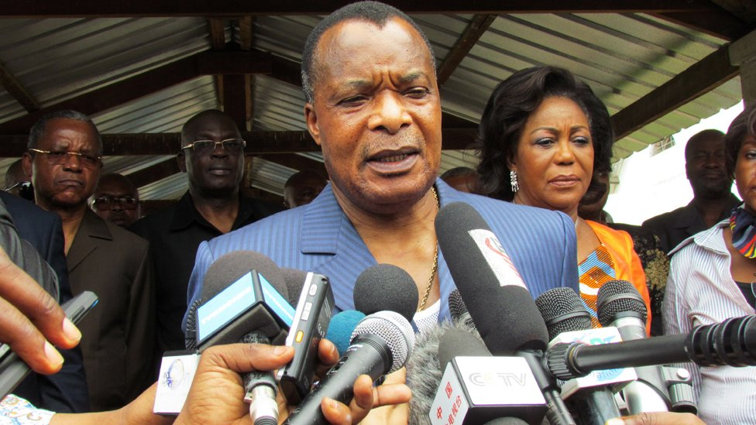image copyrightGetty Images

Denis Sassou Nguesso is one of Africa's longest-serving leaders, having first come to power almost four decades ago.

He was installed as president by the military in 1979 and lost his position in the country's first multi-party elections in 1992.

He returned to power in 1997 after a brief but bloody civil war in which he was backed by Angolan troops.

He gained his latest seven-year term after elections in March 2016.

Constitutional changes to allow him to stand for another term were condemned by the opposition as a constitutional coup.

A French-trained paratrooper colonel, Mr Sassou Nguesso is seen as a pragmatist. During his first presidency in 1979-92 he loosened the country's links with the Soviet bloc and gave French, US and other Western companies roles in oil exploration and production.

But he has also been dogged by corruption allegations. In May 2009, a French judge announced an investigation into whether Mr Sassou Nguesso and two other African leaders - all of whom deny wrongdoing - had plundered state coffers to buy luxury homes and cars in France.

Scores of privately-owned radio and TV stations operate alongside the state broadcaster but they are under pressure to self-censor, says Reporters Without Borders.

Facebook is the leading social media network.

# Republic of Congo profile

Published

8 January 2018

**A chronology of key events:**

**1400s** - Bakongo, Bateke and Sanga ethnic groups arrive in what is now the Republic of Congo.

**1482** - Portuguese navigator Diogo Cao explores the coastal areas.

## French rule

**1880** - French explorer Pierre Savorgnan de Brazza negotiates an agreement with the Bateke to establish a French protectorate over the north bank of the Congo river.

**1907** - France restricts the role of concessionaires following widespread outrage at revelations of the brutalities of forced labour.

**1910** - Middle Congo, as it was known then, becomes a colony of French Equatorial Africa.

**1928** - African revolt over renewed forced labour and other abuses carried out in the course of building the Congo-Ocean railway, which resulted in the death of more than 17,000 Africans.

**1946** - Congo given a territorial assembly and representation in the French parliament.

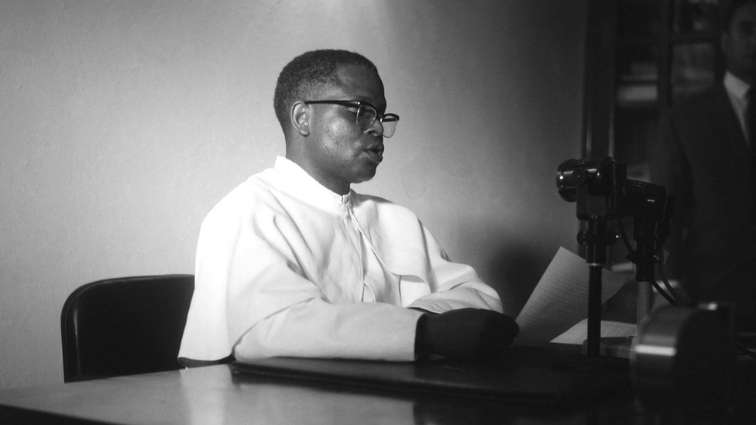image copyrightAFP

image captionCongo's first pro-independence president, Fulbert Youlou, was forced to resign by protests in 1963

**1958** - Congolese vote for autonomy within the French Community.

## Independence

**1960** - Congo becomes independent with Fulbert Youlou as president.

**1963** - President Fulbert Youlou forced to resign following workers' unrest; Alphonse Massamba-Debat becomes president and Pascal Lissouba prime minister.

**1964** - President Massamba-Debat sets up the National Revolutionary Movement as the sole party and proclaims a non-capitalist path of economic development.

**1968** - Massamba-Debat ousted in a coup led by Marien Ngouabi, who continues his predecessor's commitment to socialism but sets up his own party, the Congolese Workers Party (PCT).

**1970** - President Ngouabi proclaims Congo a Marxist People's Republic with the PCT as the sole legitimate party.

**1977** - Ngouabi is assassinated. Massamba-Debat and the Archbishop of Brazzaville, Emile Cardinal Biayenda, are killed shortly afterwards.

Joachim Yhombi-Opango becomes president.

**1979** - Joachim Yhombi-Opango hands over the presidency to the PCT, which chooses Denis Sassou-Nguesso as his successor.

**1981** - Congo signs treaty of friendship and cooperation with the Soviet Union.

**1990** - The PCT abandons Marxism.

**1992** - Voters approve a constitution which establishes a multi-party system.

Pascal Lissouba becomes president in Congo's first democratic election.

## Civil strife

**1993** - Bloody fighting between government and opposition forces over disputed parliamentary elections.

**1994**-**95** - Ceasefire between government and opposition established; opposition given government posts.

**1997** - Full-scale civil war breaks out; pro-Sassou Nguesso forces, aided by Angolan troops, capture Brazzaville, forcing Lissouba to flee.

**1999** - Government and rebels sign a peace deal in Zambia providing for a national dialogue, demilitarisation of political parties and the re-admission of rebel units into the security forces.

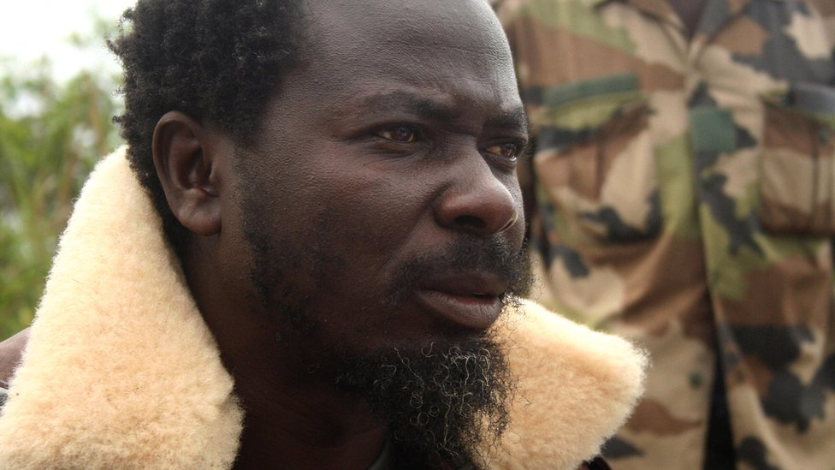image copyrightAFP

image captionPastor "Numi" was co-leader of the Ninja rebels before joining mainstream politics in 2007

**2001** April - Peace conference ends by adopting a new constitution, paving the way for presidential and parliamentary elections.

**2001** September - Transitional parliament adopts a draft constitution. Some 15,000 militia disarm in a cash-for-weapons scheme. IMF starts clearing Congo's $4bn debt.

**2001** December - Former president, Pascal Lissouba, convicted in absentia on treason and corruption charges, and sentenced to 30 years' hard labour by the high court in Brazzaville.

**2002** January - About 80% of voters in constitutional referendum approve amendments aimed at consolidating presidential powers.

**2002** March - Denis Sassou Nguesso wins presidential elections unopposed after his main rivals are barred from the contest.

## Clashes with rebels

**2002** March - Intense fighting between government and "Ninja" rebels drives many thousands of civilians from their homes in Pool region. The rebels, loyal to former PM Bernard Kolelas and led by renegade priest Pastor Ntumi, name themselves after the famous Japanese warriors.

**2002** June - Government troops battle Ninja rebels in Brazzaville. About 100 people are killed.

**2003** March - Government signs deals with Ninja rebels aimed at ending fighting in Pool region. Ninja leader Pastor Ntumi agrees to end hostilities and allow the return of the rule of law.

**2004** June - World diamond trade watchdog removes Congo from list of countries recognised as dealing legitimately in diamonds.

**2005** April - Government says a group of army officers, arrested in January over an arms theft, had been planning a coup.

**2005** October - Former PM Bernard Kolelas is allowed home to bury his wife after eight years in exile, during which he was sentenced to death on war crimes charges. He is given an amnesty in November.

**2006** January - Congo is chosen to lead the African Union in 2006 after disagreements within the body about Sudan's leadership bid.

President Sassou Nguesso accuses France of interfering in his country's affairs, following a decision by a French appeal court to reopen an investigation into the disappearance of more than 350 refugees in 1999.

**2007** June - Former "Ninja" rebels led by renegade Pastor Frederic Ntumi ceremoniously burn their weapons to demonstrate their commitment to peace.

**2007** June-August - Parliamentary elections, boycotted by some 40 parties. Ruling party wins 90% of seats.

## Debt cancelled

**2007** November - London Club of private sector creditors cancels 80% of Congo's debt.

**2009** May - French magistrate opens probe into alleged embezzlement by President Sassou Nguesso and two other African leaders following lawsuit by an anti-corruption group.

**2009** July - President Denis Sassou Nguesso gains another seven years in power following elections boycotted by the opposition.

**2010** March - Paris Club of creditor countries and Brazil agree to cancel all the debt owed to them by Congo - about $2.4 billion.

**2010** November - French appeal court gives go-ahead for probe into corruption charges against three African leaders, including President Denis Sassou Nguesso.

**2012** March - An ammunition dump in Brazzaville explodes, killing 282 people and injuring more than 2,300.

**2013** February - Congo declared to be compliant with standards set by the Extractive Industries Transparency Initiative for the disclosure of revenues from oil.

**2013** May - Brazil says it will cancel or restructure $900m of debt with Africa, including Congo, which has the highest debt with Brazil.

**2014** May - UN says the repatriation of 130,000 DR Congo nationals from Republic of Congo over past month has caused a humanitarian crisis.

## Constitution referendum

**2015** October - Voters in referendum approve constitutional changes allowing the president to run for a third term. The opposition boycotts the vote and says the result is fraudulent.

**2016** March - President Denis Sassou Nguesso gains another term following an election described as fraudulent by the opposition.

**2016** April - Government buildings in Brazzaville are attacked in post-election unrest.

**2017** June - The UN says the Congo Republic will withdraw its troops from a UN peacekeeping mission in Central African Republic after a review sparked by sexual abuse accusations found "systemic problems in command and control."

**2017** December - The government and the rebel group known as Ninjas sign a ceasefire deal.